GenAI Lab-1
Notes and Analysis

SRN:PES2UG23CS911
Name: Anushree Sanjeev Sawant
Section: B

Analysis: Compare the two outputs. Does the standard model stay more on topic? Does the fast model drift into nonsense?

DistilGPT-2 (Fast Model): The DistilGPT produces very short output. It starts on the correct topic showing word repetition (“learning, and learning”). It seems to lack depth and explanation in answering It does not strongly drift, but feels incomplete and shallow
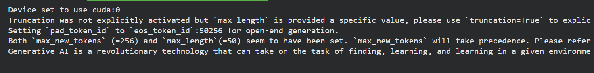Latency is low in distil models. They answer faster.
In the case of GPT-2 (Standard Model)
Predicts the next sentence with better efficiency. It produces longer, more detailed text. The outputs tend to stay on the main topic for a longer duration, giving better sentence fluency and structure. The model gradually drifts into loosely related topics (mental health, cognition)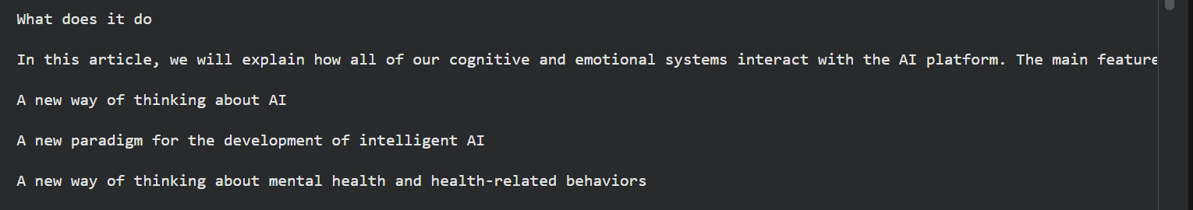
We see that the model still remains semantically meaningful, not pure nonsense. It is more suitable for paragraph-level explanations.

Temperature in gpt2 : this controls randomness in the output. Basically temperature scales the probability distribution over next tokens and controls creativity and uniqueness. This is usually applied before sampling.

-> We do tokenisation because ML model can understand numeral values. They cannot operate on English sentences directly. In tokenization we break a text sequence into smaller units called tokens, which may be words, sub-words, or characters, and assigns each token a unique numerical ID. This transformation allows textual input to be represented in a mathematical form that models can process.
Seed =42

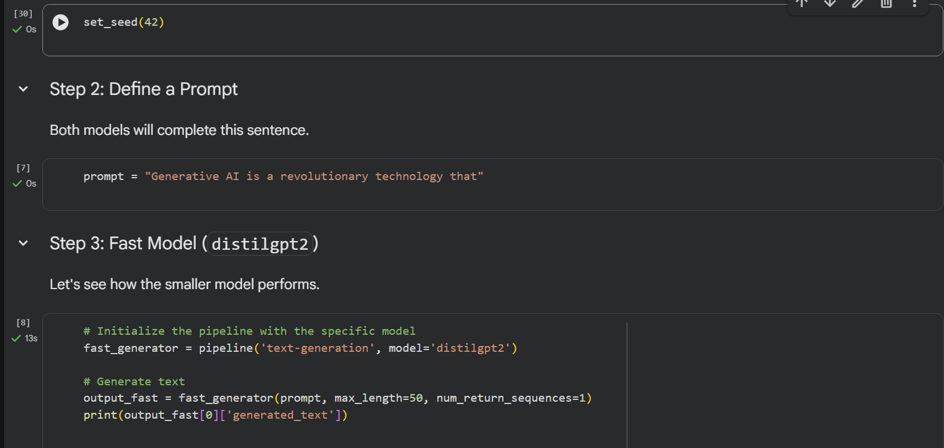
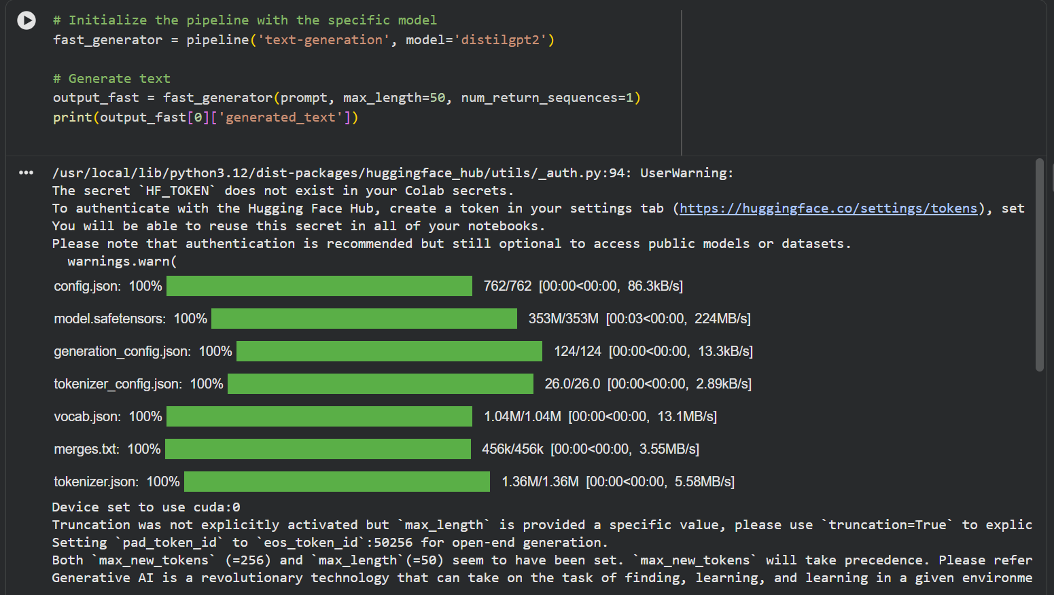
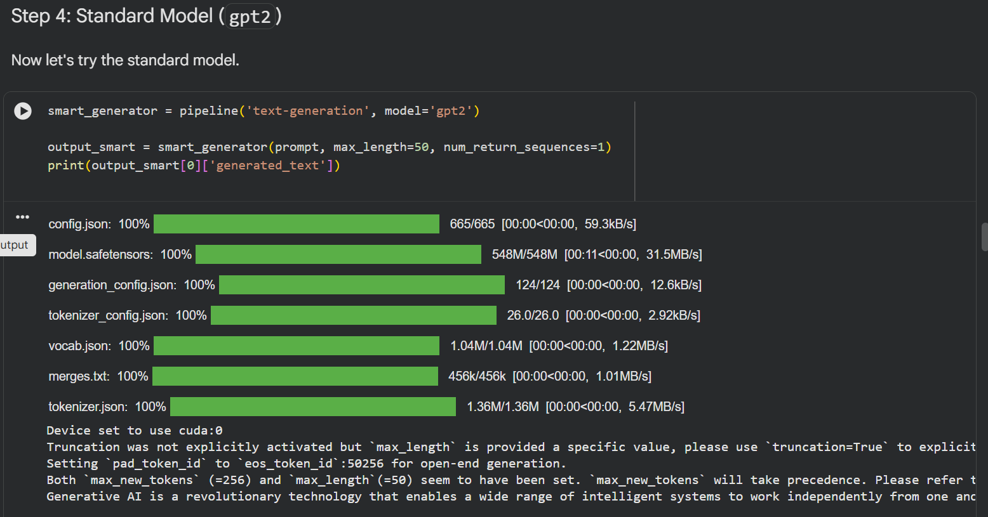
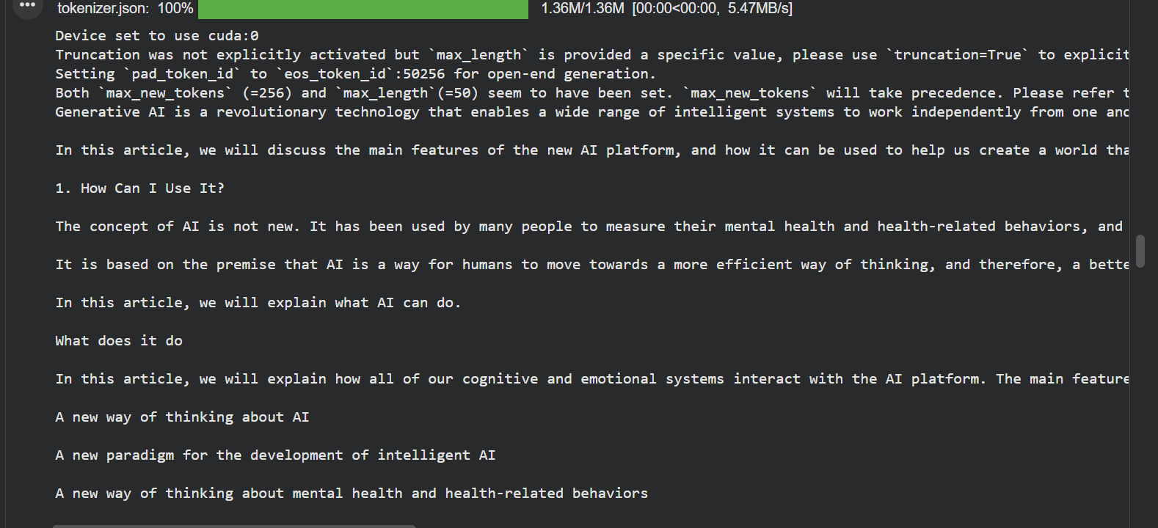

Seed = 70

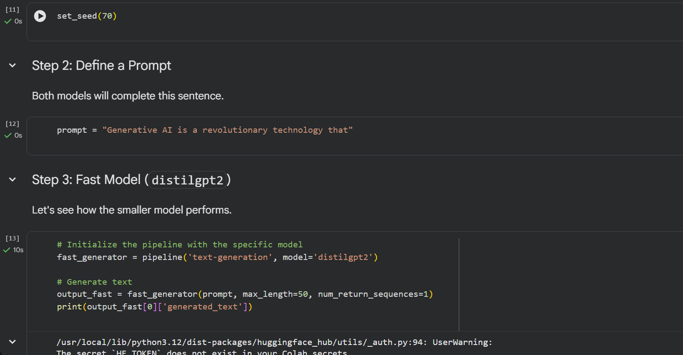
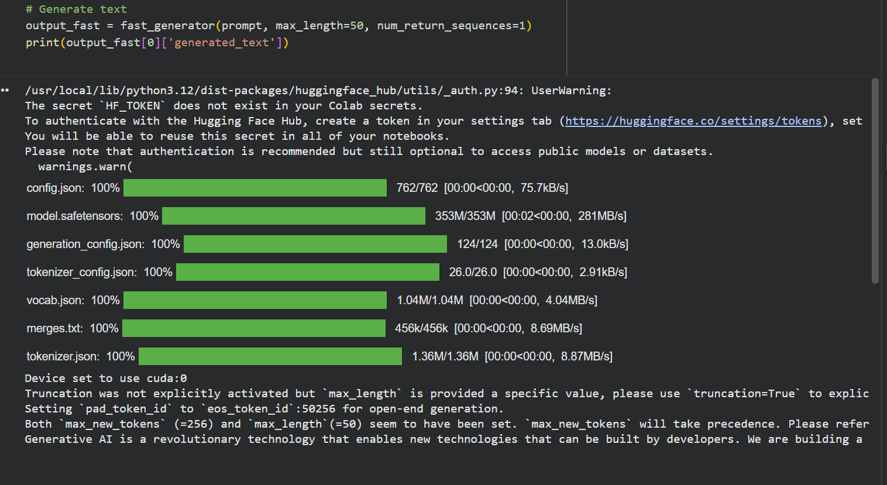
Output but Distill model:
Generative AI is a revolutionary technology that enables new technologies that can be built by developers. We are building a new AI that is able to be used in any form of research, technology or engineering, and is capable of doing so in a number of different ways.

Output but GPT2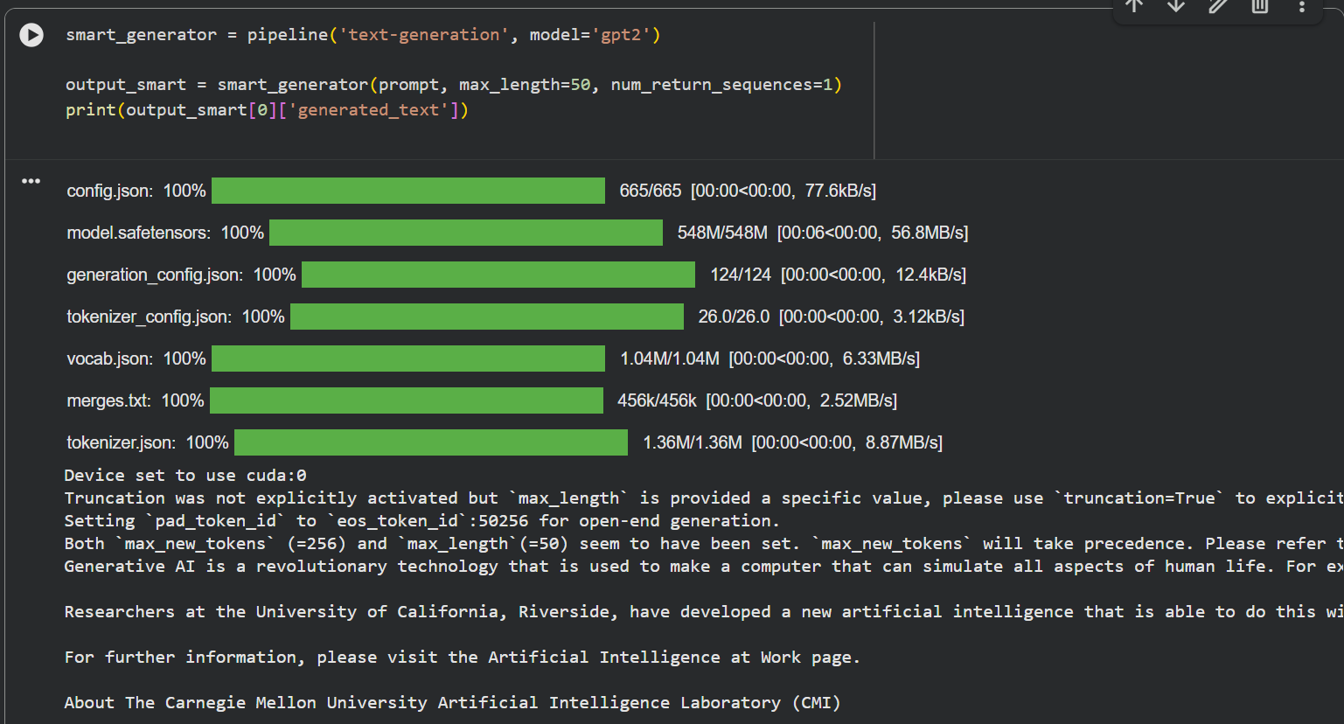

Generative AI is a revolutionary technology that is used to make a computer that can simulate all aspects of human life. For example, an artificial intelligence can understand human emotions and behavior, but can also learn things about how to deal with a variety of challenges.

Researchers at the University of California, Riverside, have developed a new artificial intelligence that is able to do this without requiring a human to be there. The company is now working on a novel algorithm to see how a human could work with AI. The team is also working on the creation of a computer that can recognize human emotions.

For further information, please visit the Artificial Intelligence at Work page.

About The Carnegie Mellon University Artificial Intelligence Laboratory (CMI)

CMI is a U.S. graduate research center that is home to some of the world's most innovative and innovative emerging technologies. Carnegie Mellon is a key partner in developing disruptive research projects. Through its faculty, alumni and employees, CMI is a leading research university that is a world leader in the field of artificial intelligence.

For more information, please visit www.cmiller.columbia.edu.

->POS
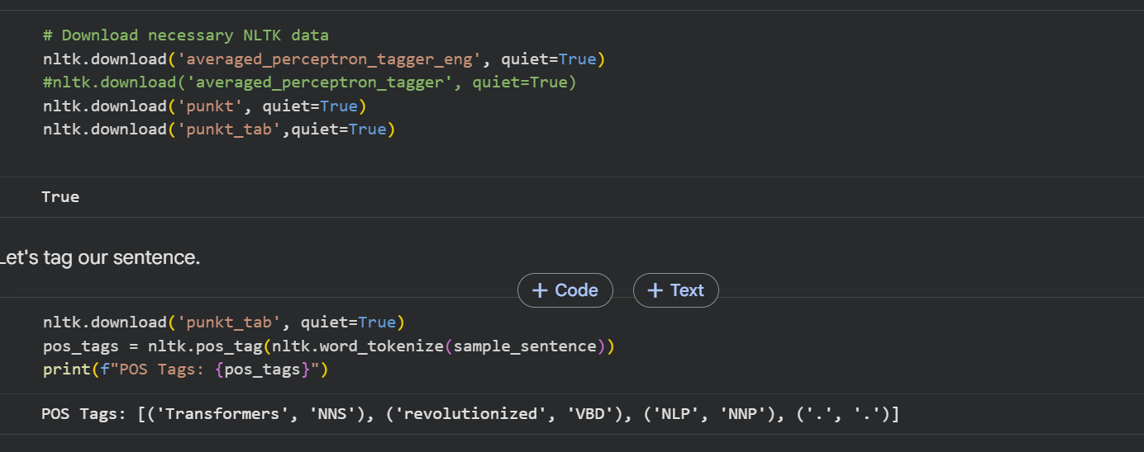
NNS:Noun Plural
VBD: Verb Past Tense
NNP:Proper noun singular

Other parts of speech :
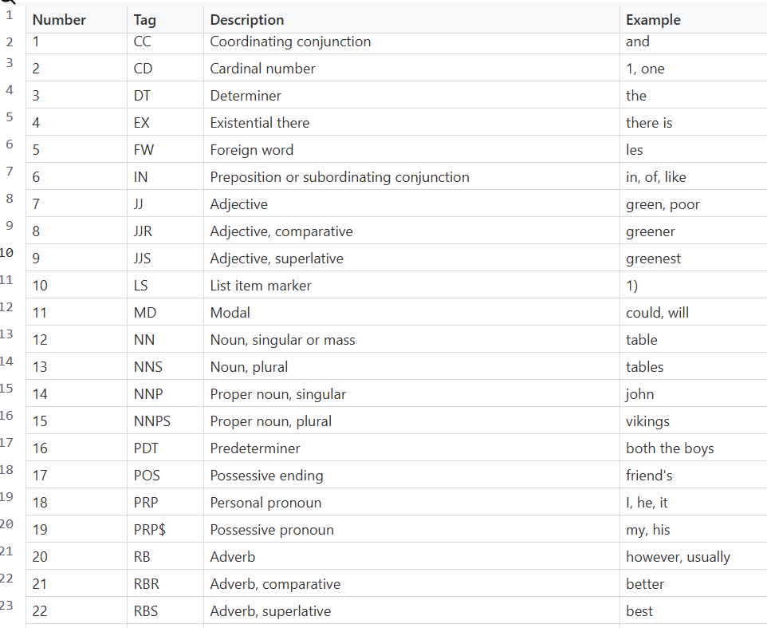
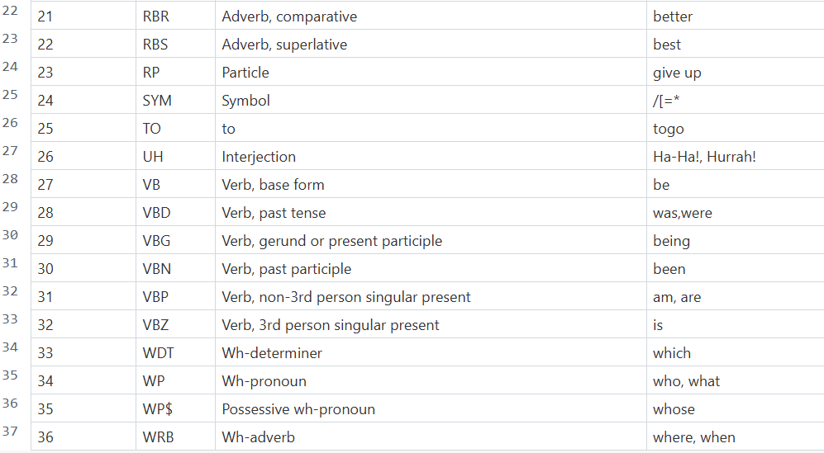

->Named Entity Encoder(NER)
Iteration is done from both sides to understand complete context. BERT is one of the way how we do NER.
Named Entity Recognition (NER) is an important Natural Language Processing (NLP) task that involves identifying and classifying named entities in text into predefined categories such as Person, Organization, Location, Date, Time, and Monetary values. To accurately recognize entities, the model must understand the complete context of a word, since the same word can represent different entities depending on how it is used. Therefore, contextual understanding from both left and right sides of a word is crucial.

->BERT is used for summarization. It has both encoder and decoder.
BERT itself is an encoder-only model and does not contain a decoder. It is mainly used for extractive summarization, where it identifies and selects the most important sentences from a document.It cannot generate new sentences on its own.
For abstractive summarization, models like BART or T5 are used, as they include both encoder and decoder components. These models can understand the input text and then generate a concise summary in natural language.

